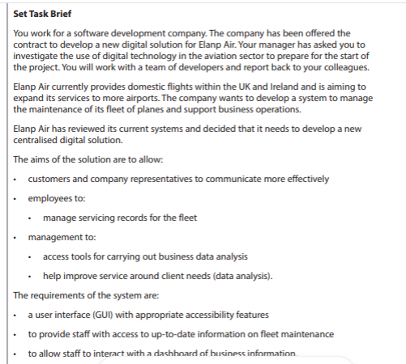
Create a dashboard integrated with the businesses databases and a easy to use navigation to allow staff to access a variety of business information
Insist on gaining client feedback from trips to help

Insist on gaining client feedback from trips to help make update
Allow staff access to the database covering fleet maintenance and logs
Insist on gaining client ffeedback from trips to help
Integrations of database into a staff portal
Live Chat?

